Hive Assignment
Airlines Question -1
Section A: Basic Hive Operations (5 Questions)
- Show all databases available in Hive.
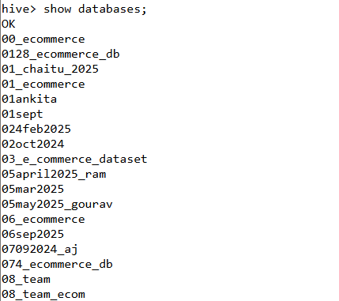

- Switch to the database named one.
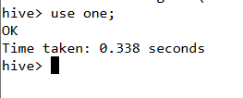
- List all tables present in the current database.
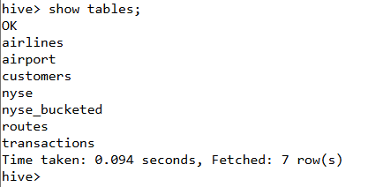
- Display the structure of the airport table.

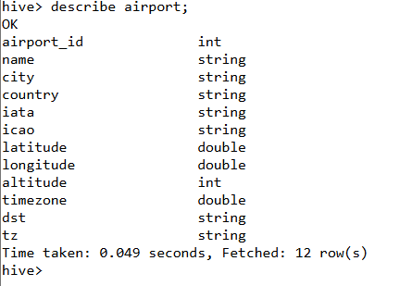
- Display the first 10 records from the airlines table.
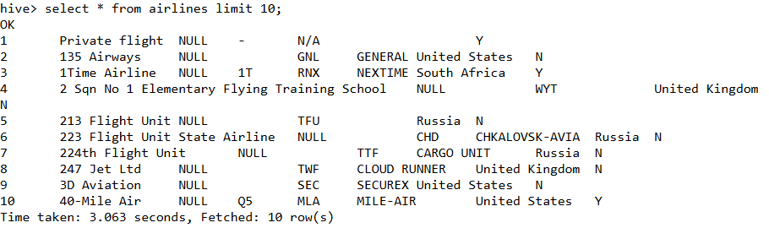

Section B: Filtering and Simple Queries (5 Questions)
- List all airports located in Greenland.
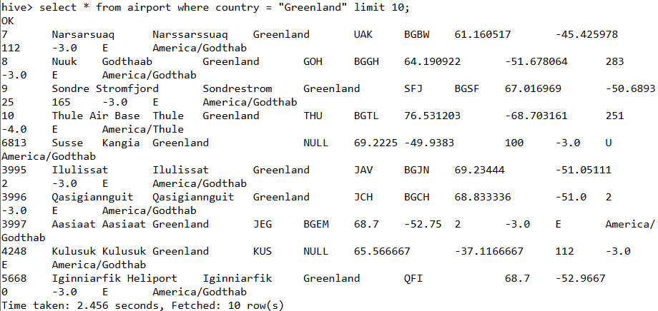

- Find all active airlines.
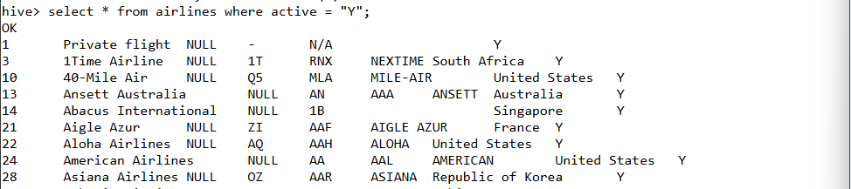
Total 1161 Active airlines.

- Display all routes where the number of stops is greater than 0.
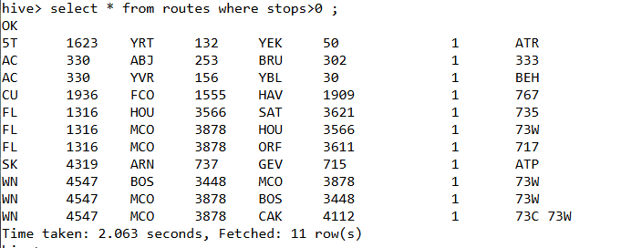
- Show details of airports located in Papua New Guinea.
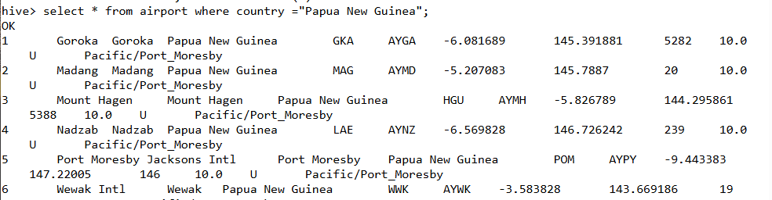
Total – 57 Airport.
- Display all flights where the destination airport ID is missing (NULL).
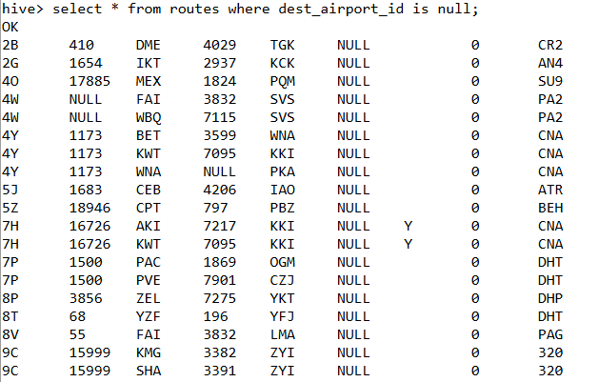
Tota – 242 Routes have a Null value.

Section C: Aggregations (5 Questions)
- Count the total number of records in the airport table.
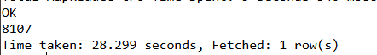Total – 8107 Rows
- Find the number of distinct countries in the airport table.
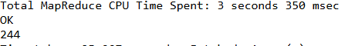
The total Countries is 244

- Find the average altitude of airports by country.
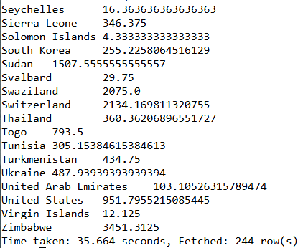
- Find the maximum traded volume for each stock symbol in nyse.
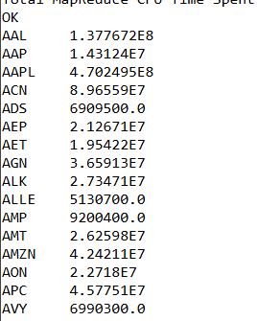 T
- Find the average closing price per symbol in nyse.
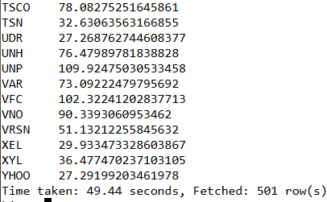

Section D: Group By and Having (5 Questions)
- Find the number of airports in each country.
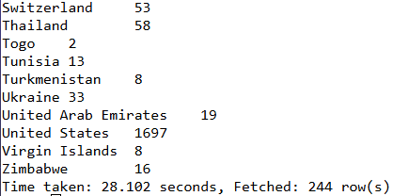
- List countries having more than 50 airports.
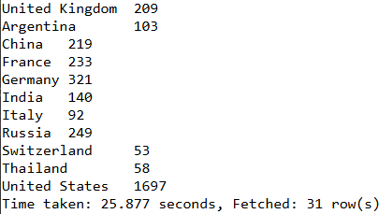
- Find the number of active and inactive airlines per country.
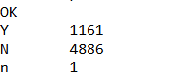

- Show the total number of routes operated by each airline.
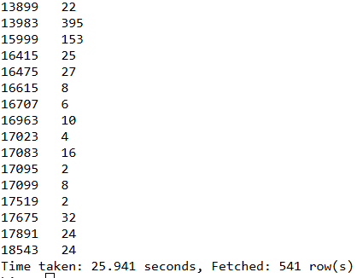
- List airlines that operate more than 100 routes.
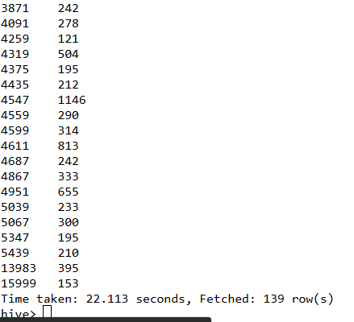

Section E: Joins (8 Questions)
- Join the routes and airlines tables to display airline name and the equipment used.
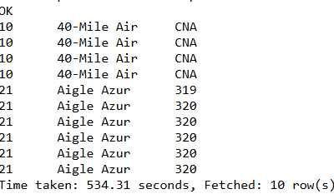
- Find the source and destination airport names for each route.
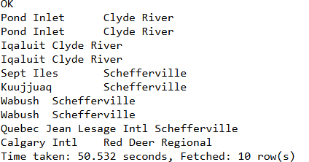
- Display routes where both source and destination airports are in the same country.
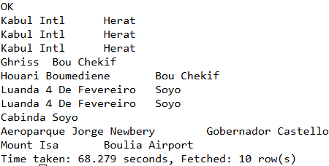
- List all routes operated by Russian airlines.
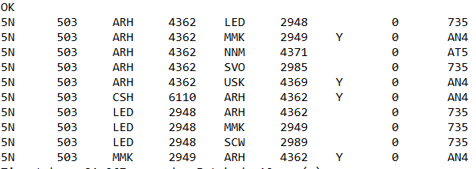

- Show all unique pairs of source and destination cities for airline 2B.
- Find the total number of routes operated by each airline country.
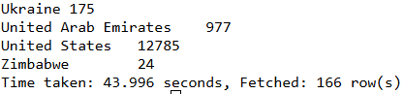
- Join routes with the airport to find the city names of the source and destination.
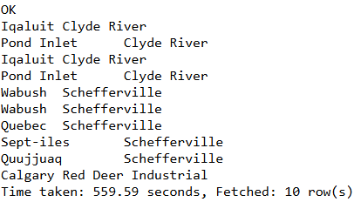
- Find the airline name, source city, and destination city for all flights that stop once.
Empty

Section F: Date and String Functions (5 Questions)
- Extract the year from the stk_date column in NYSE.
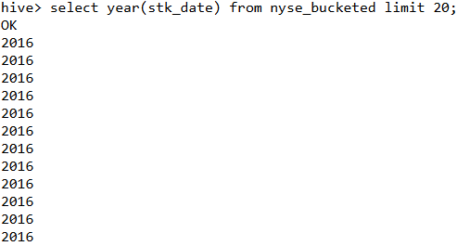
- Count how many records exist for the year 2016 in the NYSE.
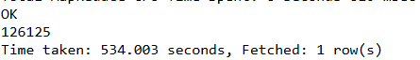
- Find symbols whose name starts with the letter ‘A’.
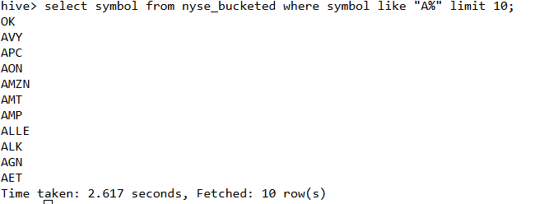
- Display all airport names in uppercase.
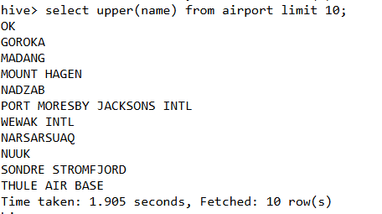
- Find all airlines whose callsign contains the word “AIR”.
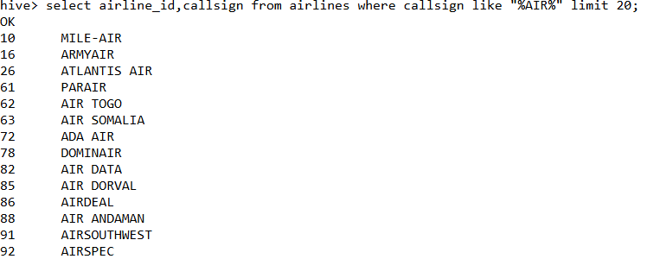

Section G: Partitioning and Optimization (3 Questions)
- Create a partitioned table nyse_partitioned based on year.
- Load data into the partitioned table using dynamic partitioning.
- Show all partitions created in the NYSE_partitioned table.
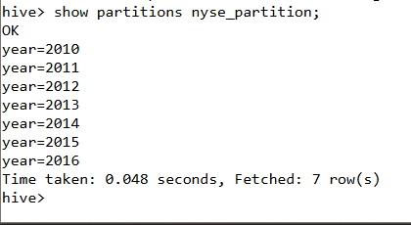

Section H: Analytical and Complex Queries (4 Questions)
- Find the top 5 airports with the highest altitude.
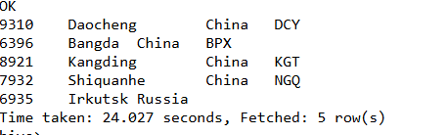
- Find the top 5 most frequently used destination airports in routes.
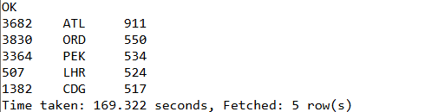

- Rank airlines by the number of routes they operate.
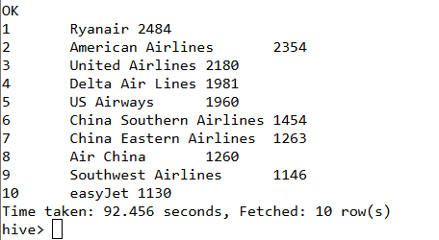
- Find the total traded volume per year for each stock symbol in nyse.
